**PIZZA SALES SQL QUERIES**

1. **KPI’s**
2. **Total Revenue**

select sum(total_price) as total_revenue from pizza_sales;



1. **Average Order Value**

 select sum(total_price) / count(distinct order_id) as Average_order_Value from pizza_sales;

1. Total Pizza Sold

 select sum(quantity) as Total_pizza_sold from pizza_sales;

1. Total Orders Placed

select COUNT(DISTINCT order_id) AS Total_Order_Placed FROM pizza_sales;

1. Average Pizza per Order

 select CAST(CAST(sum(quantity) AS DECIMAL(10,2)) / CAST(count(distinct order_id) AS DECIMAL(10,2)) AS DECIMAL(10,2)) as Average_pizza_per_Order from pizza_sales;

1. **CHART REQUIREMENT**
2. **Daily trend for total orders**

select DATENAME(DW, order_date) AS order_day, COUNT(DISTINCT order_id) AS total_orders from pizza_sales

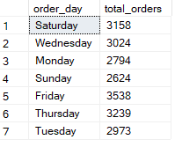group by DATENAME(DW, order_date);

1. **Monthly Trend by Total Orders**

SELECT DATENAME(MM, order_date) AS order_month, COUNT(DISTINCT order_id) as total_orders

from pizza_sales

group by DATENAME(MM, order_date)

order by total_orders DESC;

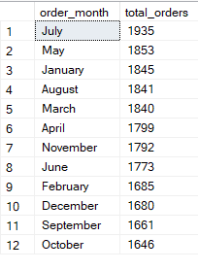

1. Percentage of sales by Pizza Category

SELECT pizza_category, sum(total_price) as Total_Sales, (sum(total_price))*100 / (SELECT SUM(total_price) from pizza_sales WHERE MONTH(order_date)=1) AS PCT

from pizza_sales

where MONTH(order_date) = 1

group by pizza_category;

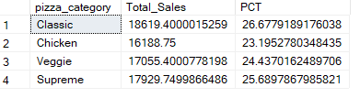

1. Percentage of sales by pizza category

SELECT pizza_size, sum(total_price) as Total_Sales, CAST((sum(total_price))*100 / (SELECT SUM(total_price) from pizza_sales) AS DECIMAL(10,2)) AS PCT

from pizza_sales

group by pizza_size

order by PCT DESC;

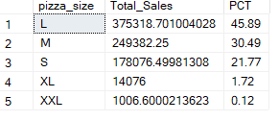

1. Top 5 best sellers by revenue

SELECT top 5 pizza_name, sum(total_price) as total_revenue from pizza_sales

group by pizza_name

order by total_revenue DESC;

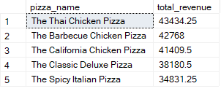

1. Bottom 5 best seller by revenue

select top 5 pizza_name, CAST(sum(total_price) AS decimal(10,2)) as total_revenue from pizza_sales

group by pizza_name

order by total_revenue ASC;

